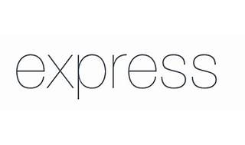



Explore

**Express.js**, also known as **Express**, is a **minimal and flexible web application framework** built upon Node.js. [It provides a robust set of features for creating web and mobile applications, making it easy to handle routing, middleware, and APIs1](http://expressjs.com/)[2](https://developer.mozilla.org/en-US/docs/Learn/Server-side/Express_Nodejs)[3](https://kinsta.com/knowledgebase/what-is-express-js/).

Here are **five free resources** where you can learn more about Express.js:

1. [**The Official Express Docs**](http://expressjs.com/): The official documentation offers an introductory guide to using Express.js.
2. [**MDN Web Docs Express Tutorial**](https://developer.mozilla.org/en-US/docs/Learn/Server-side/Express_Nodejs): The “Local Library” tutorial on MDN Web Docs guides you through building a website to manage a local library’s catalog.
3. [**The Express Handbook**](https://www.freecodecamp.org/news/the-express-handbook/): This comprehensive handbook covers Express.js from beginner to advanced levels, including practical examples and code snippets.
4. [**Codecademy’s Learn Express Course**](https://www.codecademy.com/learn/learn-express): Codecademy offers an interactive course on creating back-end apps and APIs using Express.js.
5. [**Express Web Application Development**](https://expressjs.com/en/resources/learning.html): Explore additional learning resources, including books and tutorials, to deepen your understanding of Express.js[4](https://bing.com/search?q=expressjs+framework+free+learning+resources)[5](https://www.codecademy.com/learn/learn-express)[6](https://expressjs.com/en/resources/learning.html).

Happy learning! 🚀